CHAPTER 18: ALGORITHMS FOR QUERY PROCESSING AND OPTIMIZATION

Answers to Selected Exercises

18.13 - Consider SQL queries Q1, Q8, Q1B, Q4, Q27 in Chapter 5.

(a) Draw at least two query trees that can represented each of these queries.
Under what circumstances would you use each of your query trees?

(b) Draw the initial query tree for each of these queries; then show how the
query tree is optimized by the algorithm outlined in section 19.7.

(c) For each query, compare your on query trees of part (a) and the initial and
final query trees of part (b).

Answer:
Below are possible answers for Q8 and Q27.
Q8: SELECT E.FNAME, E.LNAME, S.FNAME, S.LNAME
FROM EMPLOYEE E, EMPLOYEE S
WHERE E.SUPERSSN = S.SSN
Q27: SELECT FNAME, LNAME, 1.1*SALARY
FROM EMPLOYEE, WORKS_ON, PROJECT
WHERE SSN = ESSN AND PNO = PNUMBER AND PNAME = 'ProductX'
Q8's tree1:
PROJECT E.FNAME, E.LNAME, S.FNAME, S.LNAME
E.SUPERSSN=S.SSN JOIN
EMPLOYEE E EMPLOYEE S
Q8'S tree2:
PROJECT
CARTESIAN PRODUCT
EMPLOYEE E EMPLOYEE S
E.FNAME, E.LNAME, S.FNAME, S.LNAME
SELECT E.SUPERSSN=S.SSN
The initial query tree for Q8 is the same as tree2 above; the only change made by the
optimization algorithm is to replace the selection and Cartesian product by the join in
tree1. Thus, tree 1 is the result after optimization.
Q27's tree1:
PROJECT FNAME, LNAME, SALARY
PNO=PNUMBER JOIN
EMPLOYEE PROJECT
SSN=ESSN JOIN SELECT PNAME="ProductX"
WORKS_ON
Q27's tree2:
PROJECT FNAME, LNAME, SALARY
PNO=PNUMBER AND SSN=ESSN AND PNAME="ProductX" SELECT
EMPLOYEE
PROJECT
CARTESIAN PRODUCT
WORKS_ON
CARTESIAN PRODUCT
The initial query tree of Q27 is tree2 above, but the result of the heuristic optimization
process will NOT be the same as tree1 in this case. It can be optimized more thoroughly,
as follows:
PROJECT FNAME, LNAME, SALARY
PNO=PNUMBER JOIN EMPLOYEE
PROJECT
SSN=ESSN JOIN
SELECT PNAME="ProductX" WORKS_ON
The reason is that the leaf nodes could be arranged (in Step 3 of the algorithm outlined on
page 613) so that the more restrictive selects are executed first.

18.14 - A file of 4096 blocks is to be sorted with an available buffer space of 64 blocks. How many passes will be needed in the merge phase of the external sort-merge algorithm?

Answer:
We first need to compute the number of runs, n , in the merge phase.
R
Using the formula in the text, we have
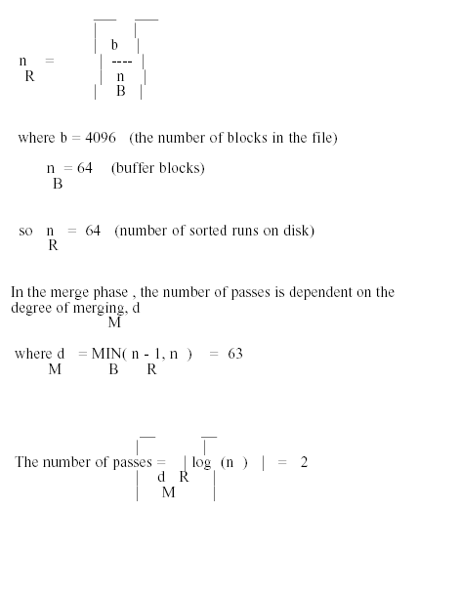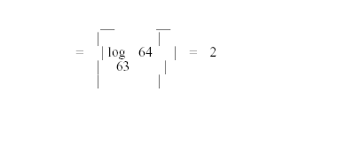

18.15 - Can a nondense (sparse) index be used in the implementation of an aggregate operator? Why or why not?

Answer:
A nondense (sparse) index contains entries for only some of the search values. A primary index is an example of a nondense index which includes an entry for each disk block of the
data file rather than for every record.
Index File Data File
Key ----------
_____ ---------------> | 10 ... |
| | | | 12 ... |
| 10 | | | 18 ... |
| --|------ ----------
| | -----> ----------
| 22 | | | 22 ... |
| --|--------------- | 28 ... |
| | | 32 ... |
| 40 | ----------
| --|------
|____| | ----------
--------------> | 40 ... |
| 52 ... |
| 60 ... |
----------
If the keys in the index correspond to the smallest key value in the data block then the sparse index could be used to compute the MIN function. However, the MAX function could not be determined from the index. In addition, since all values do not appear in the index, AVG, SUM and COUNT could not be determined from just the index.

18.16 - Extend the sort-merge join algorithm to implement the LEFT OUTER JOIN operation.

Answer:
The left outer join of R and S would produce the rows from R and S that join as well as the rows from R that do not join any row from S. The sort-merge join algorithm would
only need minor modifications during the merge phase. During the first step, relation R would be sorted on the join column(s).
During the second step, relation S would be sorted on the join columns(s).
During the third step, the sorted R relation and S relation would be merged. That is, rows would be combined if the R row and S row have the same value for the join column(s).
In addition, if no matching S row was found for an R row, then that R row would also be placed in the left outer join result, except that the corresponding attributes from the S
relation would be set to NULL values. (How a null value is to be represented is a matter of choice out of the options provided in a DBMS.)

